eduroam: Set your network password

If you were unable to connect using SecureW2 software, please proceed to clear any previous settings on your computer prior of re-adding the “eduroam” WiFi connection.

1. Visit <https://apps.cpp.edu/idm/user_account.aspx> to login and set your network password.
2. Next, click on the Account and “Change My Network Password”  
   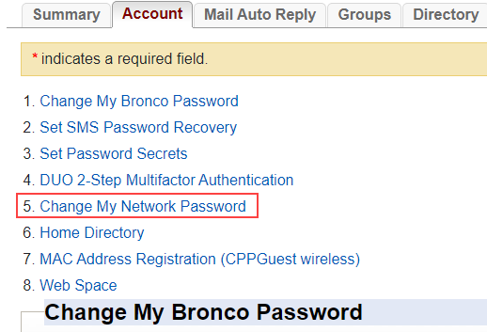
3. Set your new Network Password and click on the button “Change Network Password”.  
     
   NOTE: The password cannot be the same as your bronco password.  
     
   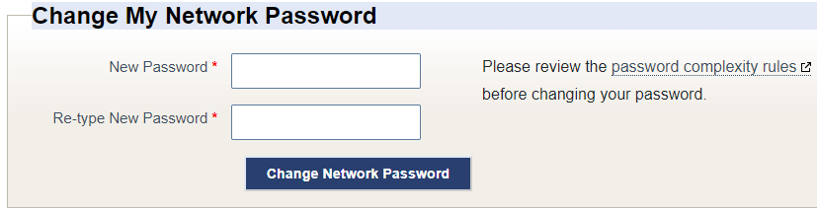
4. You’re now able to use this password to connect to the “eduroam” WiFi.  
     
   NOTE: For username, you will need to enter as [billy_bronco@cpp.edu](mailto:billy_bronco@cpp.edu).